**Ysgol Maesydderwen**



**Working Together, Achieving More**

**Key Stage 4 Information Booklet**

**Supporting your child at home**

Years 10 and 11 can be a stressful time for both you and your child. Examinations, coursework deadlines and day to day tasks can seem like a mountain to climb.

Starting preparation early, along with knowing exactly what needs to be done is the key to achieving.

Whilst working through their Key Stage 4 studies, your child will likely face challenges that may casue them unease. This brief guide includes pointers and information that they should find useful. The importance of attendance is also stressed, along with the need to be prepared each day for the challenges faced leading up to examinations.

**Key points to help your child succeed:**

-Ensure that your child attends school regularly and punctually

-Talk about your child’s learning with them. Let us know if and when they encounter problems so that we can help solve them

-Ensure that your child has a quiet, calm place to work at home without distractions (e.g. televisions/games consoles/mobile phones)

-Help prioritise your child’s workload – they may have a number of tasks that require completion and may struggle to ‘see the wood for the trees’

-Contact your child’s Progress Tutor/Progress Leader if you have any concerns/queries

-Attending your child’s Parents’ Evening with your child will allow their teachers to give specific feedback and further pointers and support

**Key Dates for the diary**

16/11/21 Year 10 and 11 Interim Reports

2/12/21 Year 10 Parents’ Evening

18/1/22 Year 10 Interim Reports

31/1/22 Year 11 Full Reports

3/2/22 Year 11 Parents’ Evening

11/3/22 Year 10 Full Reports & Y11 Interim Reports

**Exam Information**

|  |  |
| --- | --- |
| **Subject** | **Nature/Timing of Assessments** |
| Mathematics | Entry Level (Year 10 ASPIRE group Summer 2022)  Written Exams – summer 2022 for Year 11 |
| Numeracy | Written Exams – summer 2022 for Year 11 |
| English Language | Speaking Exam – Spring Term 2022; Written Exams – Summer 2022 (Year 11) |
| English Literature | January 11th 2022 – written paper (Year 10) |
| Science | Biology/Chemistry/Physics – unit examinations in summer exam session Years 10 & 11  Entry Level – Units 1&2 by Summer 2022, Unit 3 Summer 2023 (Year 10) |
| PE | Practical Assessment around Easter 2022; Written Exam – Summer 2022 (10:10 class) |
| Media Studies | Written exams – Summer 2022 (10:10) |
| Art | Practical Assessment – Summer 2022 for Year 11 |
| D&T Food | Practical Assessment and Written Exam – Summer 2022 (10:10 class) |
| D&T Product Design | Practical Assessment and Written Exam – Summer 2022 (10:10 class) |
| French | Speaking Exam – Spring Term 2022; Written Exams – Summer 2022 (10:10) |
| Geography | Non-Examinable Assessment December 2021 (10:10 class) |
| History | Written exams – summer 2022 (10:10) |
| ICT | Written Exams – summer 2022 for Year 11 |
| Religious Studies | Written Exams for Years 10&11 in Summer 2022 |
| Equality and Diversity | No final exams |
| Welsh | Speaking Exam – Years 10&11  Written Exams – Summer 2022 for Year 11 only |

**Attendance**

Attendance to school is key. There is a strong link between attendance and examination results. The school’s **MINIMUM** **target for attendance is 95%** for all pupils.

The table below shows the extent of your child’s absence in terms of lessons. For example, a student who achieves the **minimum attendance of 95%** will miss 50 hours of learning. It must be borne in mind that this **cannot be caught up with effective teacher support**.

|  |  |  |  |
| --- | --- | --- | --- |
| **Attendance during one school year** | **Equals days absent** | **Approximate number of weeks absent** | **Number of lessons missed** |
| 95% | 9 days | 2 weeks | 50 lessons |
| 90% | 19 days | 4 weeks | 100 lessons |
| 85% | 29 days | 6 weeks | 150 lessons |
| 80% | 38 days | 8 weeks | 200 lessons |
| 75% | 48 days | 10 weeks | 250 lessons |
| 70% | 57 days | 11 ½ weeks | 290 lessons |
| 65% | 67 days | 13 ½ weeks | 340 lessons |

Government research shows

**17 days absence**

**=**

**A drop of one grade in ALL subjects studied**

***Source: - Department of Education (DfE***



**Danger Zone**

A pupil who finishes an academic year with **91% HAS HAD JUST OVER 17 DAYS ABSENCE**. Government statistics show that, on average, a pupil will **drop an entire grade in EVERY subject studied**.

**How can parents help?**

Encourage your child to attend as frequently as possible. We appreciate that young people get ill and are unable to attend at times. Please however take a pragmatic approach if your child informs you that they are ill the morning of an important assessment, or on a frequent basis.

Planning holidays in accordance with the school calendar is also beneficial – avoid booking holidays during, or in the run up to examination sessions.

**Punctuality**

Excellent punctuality to school is as important as attendance. The most important 5 minutes of a lesson are where the work is introduced i.e. the start of the lesson. Missing this section of any lesson will put your child on the back foot. They will then play catch up throughout the remainder of their time in class.

|  |  |
| --- | --- |
| Lateness = Lost Learning  (Figures below are calculated over a school year) | |
| 5 minutes late each day | ~3 days lost |
| 10 minutes late each day | ~6 ½ days lost |
| 15 minutes late each day | ~10 days lost |
| 20 minutes late each day | ~13 days lost |
| 30 minutes late each day | ~19 days lost |



**Danger Zone**

As few as 17 missed days over the school year reduces your child’s chances of success. Their GCSE grades could drop by one grade across ALL subjects.

**How can parents help?**

Encourage your child to attend school on time, arriving each day ready for registration at 8.45am, along with making their way promptly from lesson to lesson. Ensure that they allow plenty of time to get ready in the morning and encourage a good routine, including an appropriate bedtime.

**Preparation for Learning and Work Ethic**

It is important that your child is properly prepared for their learning. Lost time at the start of lessons due to looking for a pen, not having the correct book or file can lead to a similar impact to poor punctuality. Your child will fall behind with their learning, and is likely to spend a significant portion of the rest of the lesson trying to catch up.

A positive work ethic is another vital component of your child’s education. Where young people value education, and arrive willing and eager to work, their outcomes remain far more positive, along with far more positive experiences both within and outside school

**How can parents help?**

Encourage your child to check that their bag is packed the night before school, that homework is completed, but not rushed and that they have the correct equipment/kit. Speak to your child on a regular basis about their time in school; encourage them to take a full part, and to try their best in all aspects of their learning.

**Opportunities for Revision and Strengthening Understanding in Learning**

There are a number of revision and support materials that we provide for learners at Ysgol Maesydderwen.

**MathsWatch**

MathsWatch is a Virtual Learning Environment (VLE) that your child can use to further progress their knowledge and understanding of topics within Mathematics. It consists of a series of support videos, each containing worked examples and questions to check and challenge understanding. It also contains past paper materials put together by your child’s teacher that, when completed will give them an indication of their working at grade.

The system is customisable by your child for their tier of entry; questions are selectable by grade level also. **MathsWatch is paid for by the school so is free to use at home.**

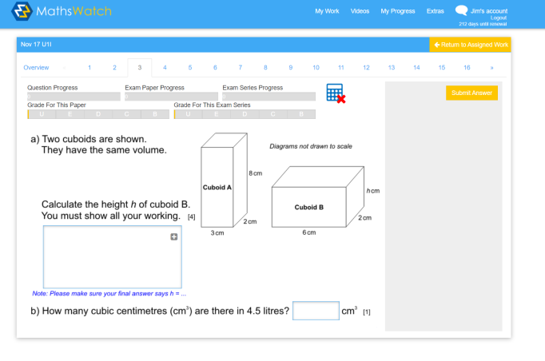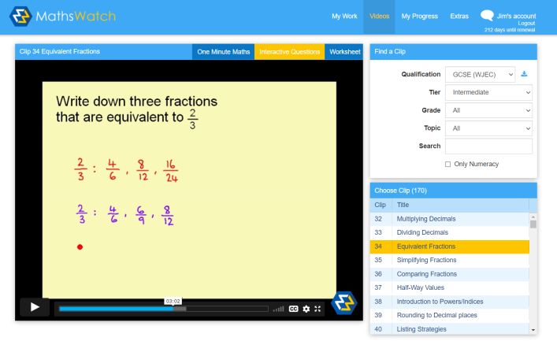

**Tassomai**

Tassomai is a quiz based system which allows your child to check and test their understanding of concepts and ideas within Science. It is based on a multiple choice quiz format that responds to what your child understands and needs further help with. There are a series of **daily goals**, which, when met regularly, not only give your child a sense of success and achievement, it allows them to make regular progress from around 10-15 minutes use per day. **Tassomai is paid for by the school so is free to use at home.**

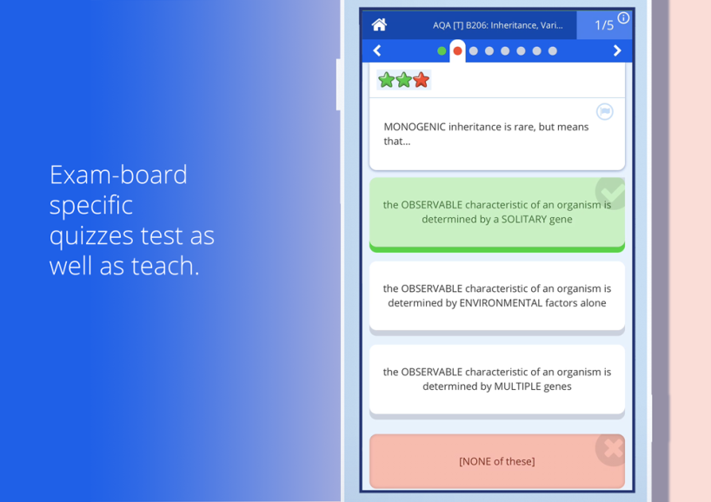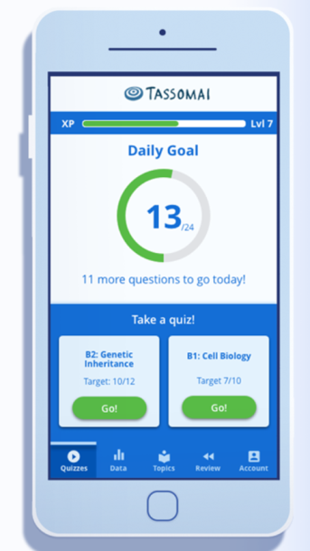

**GCSE Pod**

GCSE Pod is an online system that allows your child to watch revision Pods/videos, along with checking their understanding using quick quizzes. The system also has in-built quizzes for them to check their knowledge and understanding. **GCSER Pod is paid for by the school so is free to use at home.**

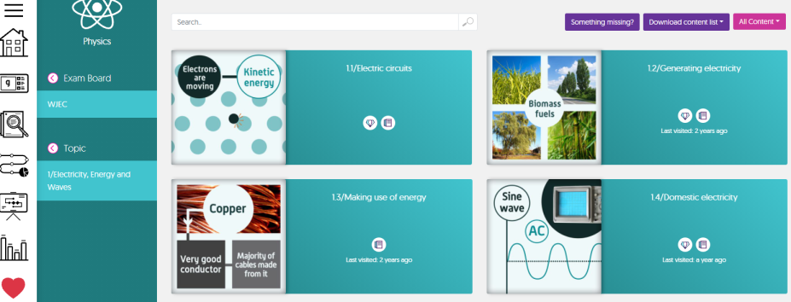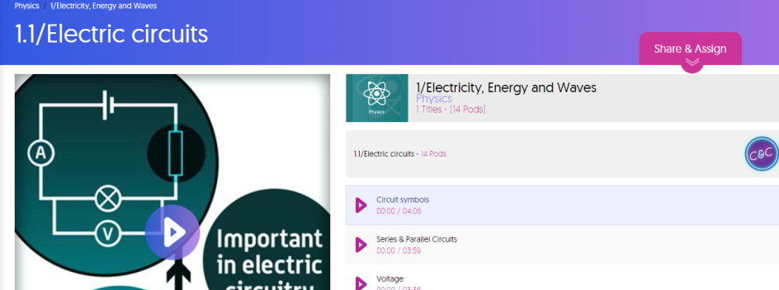

**Wellbeing Support**

The Pastoral Team are always available to support your child. Your child’s Progress Tutor is often their first port of call when they need help, guidance and advice.

|  |  |
| --- | --- |
| **Year 10 Pastoral Team** | **Year 11 Pastoral Team** |
| **10PSM** – Mr Paul Martin | **11Y** – Mrs Alyson Thomas |
| **10KR** – Mrs Emma Elliott/ Mrs Katrina Rees | **11S** Mrs Jessica Wright |
| **10KG** – Miss Katy Gullam | **11A** – Ms Jan Millar |
| **Pastoral Support Officer** – Mr Huw Thomas | **11D** – Miss Halyey Lougher |
| **Learning Support Officer** – Mrs Lucy Watkins |
| **Progress Leader for Years 10 & 11** – Mr Jim Lewis | |

**Support and Interventions**

There are a wide range of support mechanisms and interventions available at Ysgol Maesydderwen

-Progress Tutor mentoring

-Pastoral support

-Youth Intervention Service (YIS)

-In-School counsellors

-Trauma Informed Schools approaches

-KOOTH counselling services

-Behaviour support

-Emotional support

-Academic support

-Bespoke curricula

-Careers support (on-site contact)

-PSE days

-6th Form Options Process

**Reports and Targets**

Your child will be issued with a number of written reports throughout their studies. Interim reports include a record of Targets and Projected Grades, along with a score for their Attitude to Learning for each subject studied.

**Targets** – aspirational targets are set for each subject and should be seen as a minimum level for your child to aim to achieve.

**Projected Grades** – This is the grade that your child’s teacher believes is the most likely grade achievable by the time they finish the course.

**Attitude to Learning** – a score, from 1 to 4 highlighting your child’s approach, effort and willingness in working towards their target grade.

**How can parents help?**

-Talk with your child about their reports.

-Discuss which subjects they are doing well in and encourage them to further improve in ones they are finding difficult.

-Contact your child’s class teacher/Progress Tutor/Progress Leader about any concerns, or regarding help and support.

**Preparation for Mock and Final Examinations**

**Mock Examinations**

Your child will sit a series of mock examinations during their Year 10 and 11 studies. These are completed so that your child’s teachers can accurately determine which aspects of each course they need more support with, and to successfully plan support strategies. AS such it is vitally important that your child prepares for mock examinations to support further improvement in their learning.

**How can parents help?**

-Encourage your child to prepare in good time

-Plan revision out and set time aside away from work also.

-Explain that the more effective their preparation for mock examinations, the more likely your child is to do well in formal examinations.

**Final Examinations**

All students are aware of the importance of final examinations, yet sometimes fail to prepare fully or correctly for them. It is important that your child knows what assessments are to be sat, when and what will be examined in each. Your child will be issued with an examination timetable, giving the dates, times and nature of each examination.

**How can parents help?**

-Display the examination timetable somewhere prominent at home e.g. the fridge door.

-Talk to your child about the importance of effective preparation and help them plan out their time.

-Get in touch with your child’s class teacher if they require any specific help/guidance on topics, or if you have any concerns about preparation.

-Help them prepare a revision timetable, planning out their revision strategies and encourage them to stick to that plan.

-Avoid booking holidays during examination sessions, or in the run up to them. Prior to examinations, your child’s time in class is dedicated to finalising preparations for assessments.

**Exam Timetable**

|  |  |  |
| --- | --- | --- |
| Exam | Date | Time |
|  |  |  |
|  |  |  |
|  |  |  |
|  |  |  |
|  |  |  |
|  |  |  |
|  |  |  |
|  |  |  |
|  |  |  |
|  |  |  |
|  |  |  |
|  |  |  |
|  |  |  |
|  |  |  |
|  |  |  |
|  |  |  |
|  |  |  |

**Where?** Revise somewhere that you can concentrate

**When?** Not at the last minute. A little revision often works wonders!

**How?** Take regular breaks (about every 30 minutes). Fresh air and drinking water regularly will clear your mind

**Avoid: -**

* having the TV on
* having your phone/tablet nearby
* working in a cluttered environment

**Ysgol Maesydderwen**

**#WorkingTogether,AchievingMore**



**To do 2 weeks to go: -**

|  |
| --- |
|  |
|  |
|  |
|  |
|  |
|  |
|  |

**To do 3 weeks to go: -**

|  |
| --- |
|  |
|  |
|  |
|  |
|  |
|  |
|  |

**To do 4 weeks to go: -**

|  |
| --- |
|  |
|  |
|  |
|  |
|  |
|  |
|  |

**To do the final week: -**

|  |
| --- |
|  |
|  |
|  |
|  |
|  |
|  |
|  |

**Deadlines**

|  |  |
| --- | --- |
| Subject | Deadline |
|  |  |
|  |  |
|  |  |
|  |  |
|  |  |
|  |  |

**Revision Strategies: -**

* Concept maps/Mind Maps
* Flash Cards
* Teach a friend
* Cornell note taking method
* Quizzing
* Past papers

**Equipment: -**

Pens Pencils

Rubber Sharpener

Calculator Ruler

Compass

|  |  |  |  |  |  |  |  |  |  |  |  |  |
| --- | --- | --- | --- | --- | --- | --- | --- | --- | --- | --- | --- | --- |
|  | 9.00-10.00 | 10.00-11.00 | 11.00-12.00 | 12.00-1.00 | 1.00-2.00 | 2.00-3.15 | 3.15-4.30  (after school revision) | 4.30-5.30 | 5.30-6.30 | 6.30-7.30 | 7.30-8.30 | 8.30-9.30 |
| Monday |  |  |  |  |  |  |  |  |  |  |  |  |
| Tuesday |  |  |  |  |  |  |  |  |  |  |  |  |
| Wednesday |  |  |  |  |  |  |  |  |  |  |  |  |
| Thursday |  |  |  |  |  |  |  |  |  |  |  |  |
| Friday |  |  |  |  |  |  |  |  |  |  |  |  |
| Saturday |  |  |  |  |  |  |  |  |  |  |  |  |
| Sunday |  |  |  |  |  |  |  |  |  |  |  |  |

**Revision Timetable**

**Exam Countdown Revision Chart**